Mission Trip Guidelines
1
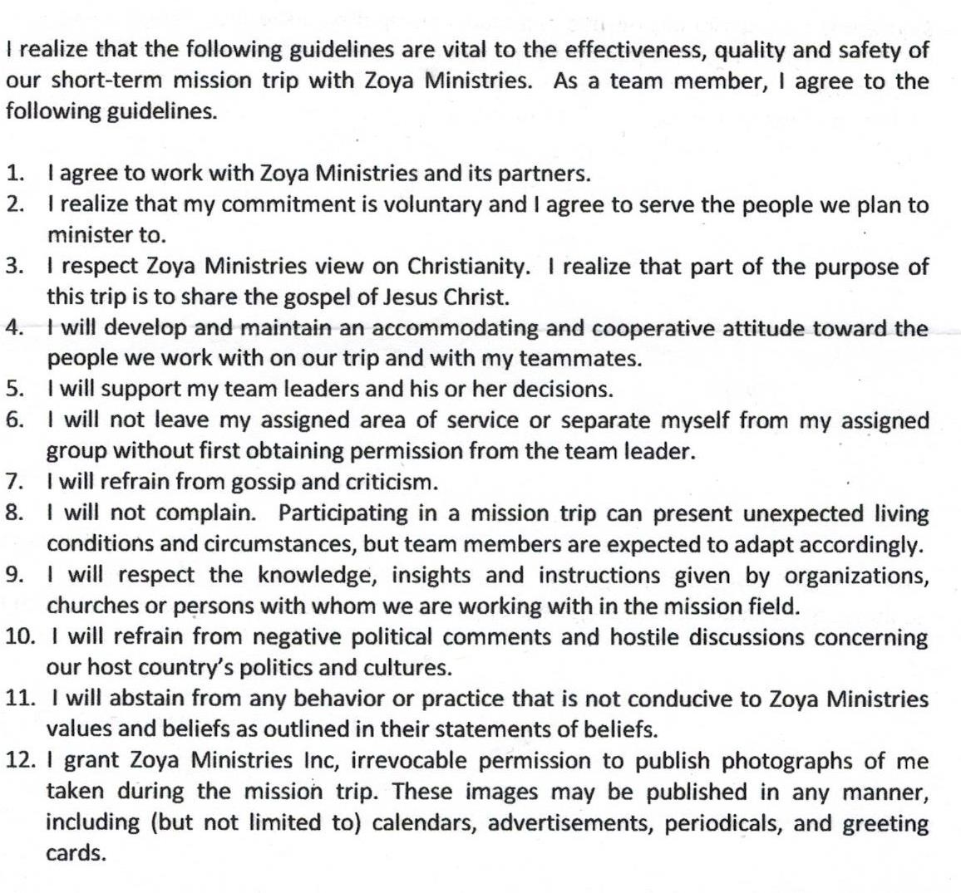
By signing the above, I promise to adhere to the rules outlines in the mission trip guidelines stated above

Signature Date

Zoya Ministries Inc., Risk and Hold Harmless Agreement
2

Whereby, I (full name) am about to travel with
representatives of Zoya Ministries, Inc. for the period of and whereas I am doing so entirely of my own initiative, risk and responsibility now, therefore, in consideration of Zoya Ministries, Inc. accepting me as a constituent trip member and undertaking to arrange all matters of transportation, lodging and other travel details, and of permitting me to assist Zoya Ministries, Inc. with medical mission clinics, I do hereby, for myself, my heirs, executors and assignees, release and forever discharge Zoya Ministries, Inc. and any of its affiliates, or subsidiaries and all of its officers, agents and employees, acting officially or otherwise, from any and all claims, demands, actions or causes of action on account of my death, or any injury to me or my personal property, which may occur from any cause, including negligence of any type, during said trip. Therefore, neither Zoya Ministries, Inc. nor its affiliates or subordinates, officers, agents and employees shall be or become liable or responsible for any loss, injury or damage to person, property or otherwise in connection with any accommodations, transportation or other services, resulting directly or indirectly from any acts of God, dangers, incident at sea, fire, breakdown in machinery or equipment, acts of government or other authorities, de jure or de facto, wars, whether declared or not, hostilities, civil disturbances, strikes, riots, thefts, pilferage, epidemics, changes in itinerary or schedules, or for any loss or damage resulting from insufficient or improperly issued passports, visas or other documents or from delay and that neither Zoya Ministries, Inc. nor any of its affiliates or subsidiaries, officers, agents and employees shall be or become liable or responsible for any additional expenses or liability sustained or incurred by the team member as a result of any of the foregoing causes.
Additionally, I acknowledge that the welfare and safety of any and all of my minor children traveling on this trip will be my sole responsibility and at my consent on their behalf that all stipulations and contingencies as stated above are applicable to them as well. Furthermore, I attest and assume sole responsibility, that my spouse and/or any other conservator with legal rights relating to the child(ren) accompanying me on this trip has been informed about the nature and risks pertaining to the trip, and has given his/her explicit consent to allow my child(ren) to participate in this trip. By doing so, my spouse and/or other legal conservator, accepts and consents to personal and equal responsibility for all the stipulated limitations of agency liability as stated above.

By executing this statement, I acknowledge that I have read, understand and accept the above terms

Signature Date

Parent or Guardian Signature Date

Zoya Ministries Inc., Risk and Hold Harmless Agreement
3

Witness

Relationship to Signor

Address City State Zip

Parent Authorization
4
Medical Release Form – (To be filled for team members under 18)
______________________________________________________
______________________________________________________
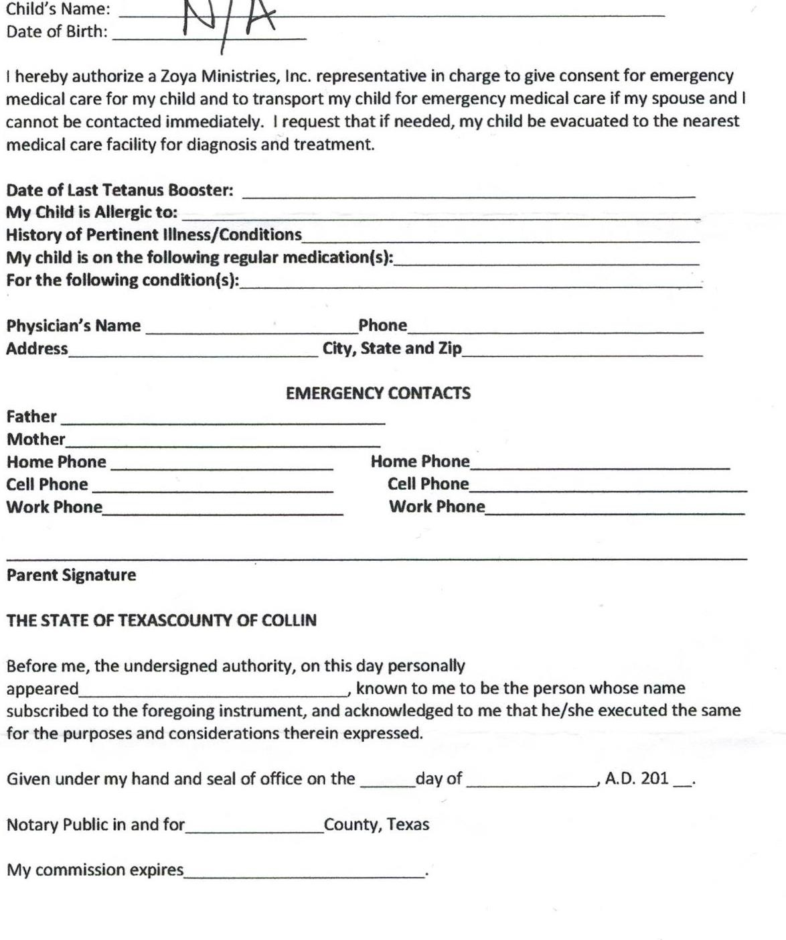

Mrs. Ms. Mr. Dr.
5
Last Name (as on Passport) |  |  | First Name | M.I. | Date of Birth
Passport Number
Address |  |  | Apt. # | Home Phone ( ) Work Phone ( ) Cell Phone ( )
City State  Zip |  |  |  | E-mail address:
U.S. Citizen ?
Yes
No
Spouse Name:
Curent Employer: |  |  |  | Job Title:
In case an emergency should occur please notify:
Name: Relation: Address:
Telephone (Day) (Evening)

Physician's Name:
Address:
Telephone (Day) (Evening)

Check any of thre following health conditions which apply to you
Heart Disease Low/High Blood Pressure Hypoglycemia Diabetes Seizures Asthma Allergies (list below) Other
Explanation of Allergies or Other:

Do you take prescription medication ona regular basis? Yes
No
If yes, please list medication, dosage and frequency:

